THE COLLABORATIVE FOR CHILDREN’S HEALTH POLICY COVID RESOURCES

Dear Child Health Advocates,
During this unprecedented health crisis, it is important that we stay informed and work together to support the needs of children and families across Illinois. The mission of the collaborative is to transform child and adolescent health and well-being in Illinois by partnering to advance policies and investments that will achieve health equity for youth, families and communities. It is now more important than ever we work together and support each other's efforts to address the unique and complex challenges that emerge from the Novel Coronavirus (COVID-19) public health crisis.
As state government moves rapidly to respond to the unprecedented situation with COVID-19, we want to provide general information on COVID-19 to our community members. Below you'll find a list of recommended resources related to COVID-19. Please note that the situation is rapidly evolving. For the most up-to-date information, please continue to refer back to the resources listed below.
Although we know that children present with a more mild form of the virus, COVID-19 will undoubtedly impact the lives of children and their families across the state. We hope that these resources will help you and the families you serve during this difficult time.
Be well, friends. Take care of yourselves and one another.

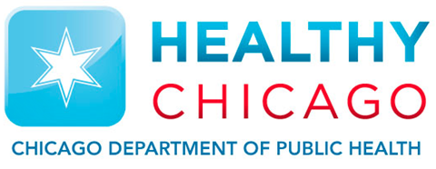 | City of Chicago Coronavirus Disease 2019 Resource  Visit CDPH site
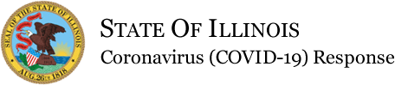 | State of Illinois Coronavirus Response  Visit Illinois.gov site

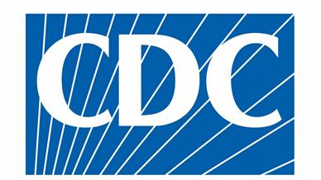 | Centers for Disease Control and Prevention Resource  Visit CDC site
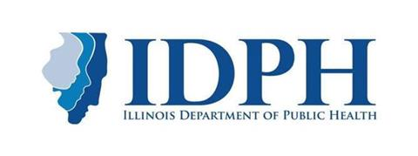 | Illinois Department of Public Health  Visit IDPH site

A Comic for Kids Exploring Coronavirus

What kids want to know about
Coronavirus
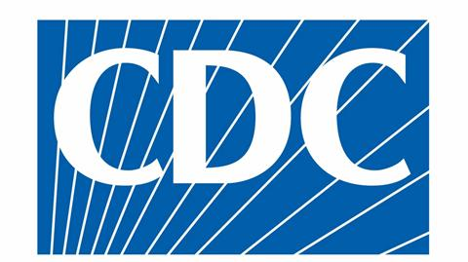 | Lo que necesita saber sobre la enfermedad del coronavirus 2019 (COVID-19)  Lo que necesita saber

What to do if you were exposed

Recommendations if exposed

